**CASE 1**

Please give example of method and response API from the case below.

Jawaban :

Metode yang dipakai pada kasus 1 adalah menggunakan metode API PUT, dikarenakan user ingin menambah fungsi lupa password. Berikut keterangan API response :

**Reset password**

Description : API ini digunakan untuk lupa password.

End point

/api/user/lupa-password

Responds: 200

Request body : {

“nik “ : “897653”

}

Respons{

“success”: ,

“data” : {

“nik “ : “897653”

},

“message”: “Your Request Success”,

“code”: 200

}

OTP

Description : API ini digunakan untuk OTP.

End point

/api/user/OTP

Responds: 200

Request body : {

“nik “ : “897653”

}

Respons{

“success”: ,

“data” : {

“user_id“ : “XXy4723”

},

“message”: “Your Request Success”,

“code”: 200

}

**New Password**

Description : API ini digunakan untuk masukkan password baru.

End point

/api/user/new-password

Responds: 200

Request body : {

“passwordBaru“ : “ ”

“ketikUlangPassword” : “ ”

}

Respons{

“success”: ,

“data” : {

“user_id“ : “XXy4723”

“nik” : “897653”

},

“message”: “Your Request Success”,

“code”: 200

}

**CASE 3**

Sequence Diagram & Activity diagram for 2 function :

Activity Diagram

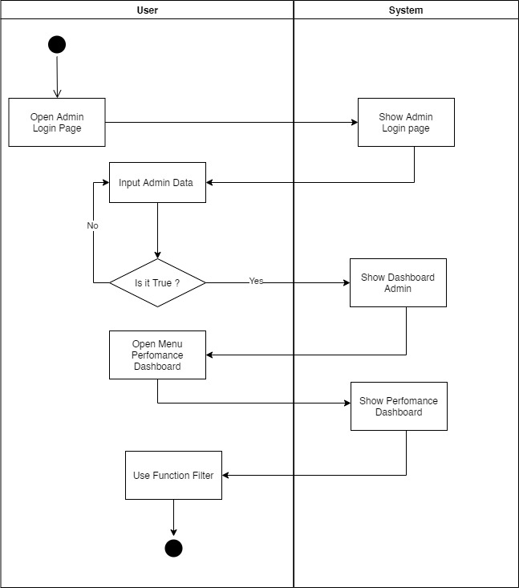

Sequence Diagram

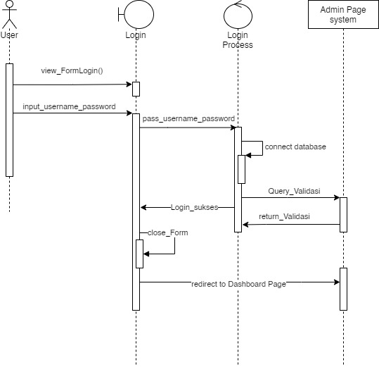

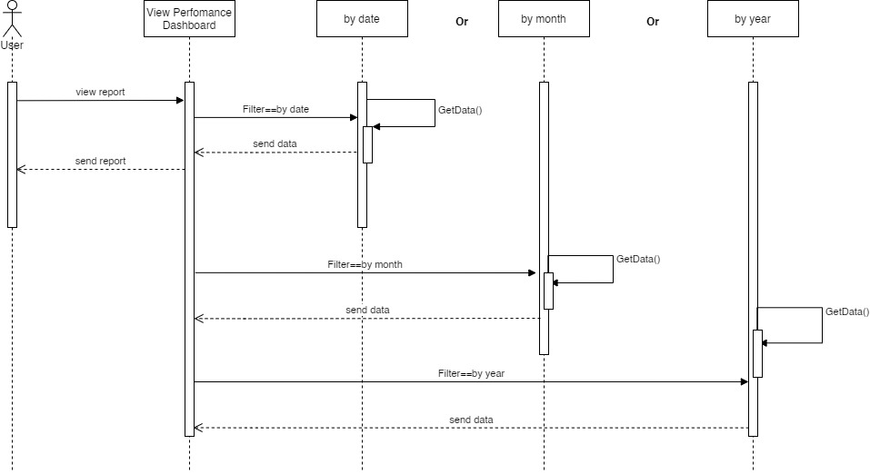

**CASE 3**

* User dapat melihat List Need Action, Reminder Kontrak dan List Approval User pada halaman dashboard.
* User dapat melihat daftar proyek

**Class Diagram**

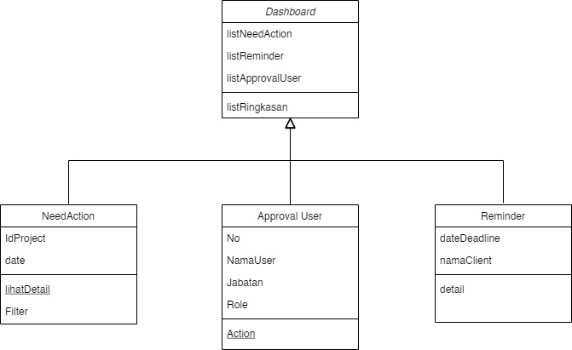

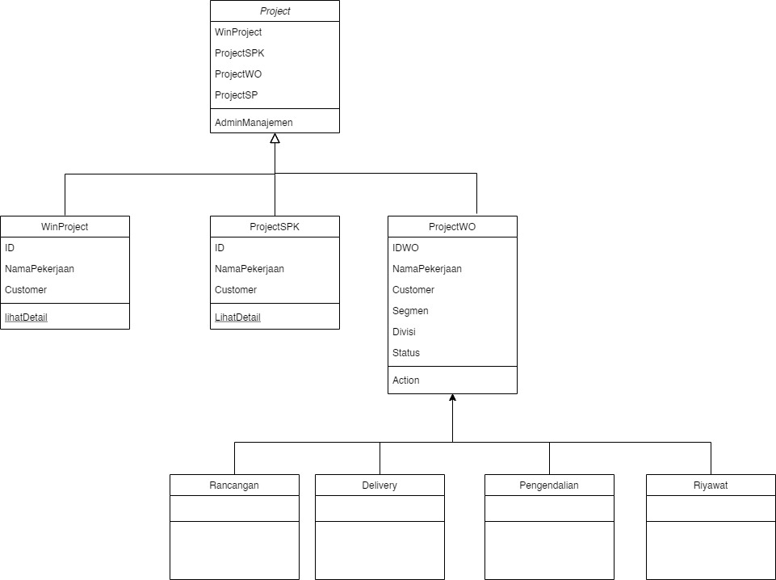

**Activity Diagram**

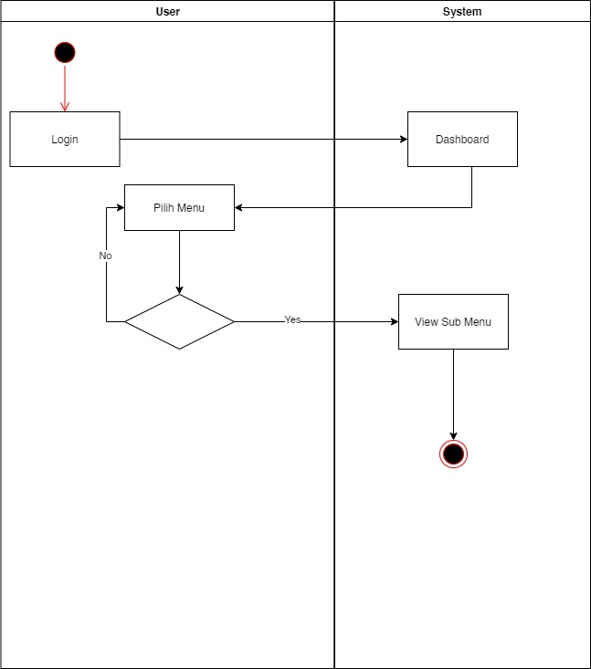

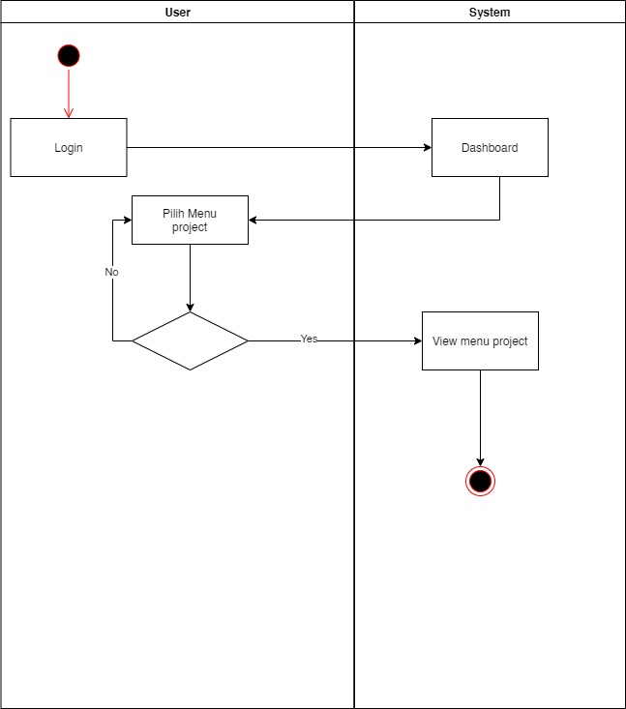

**Sequence Diagram**

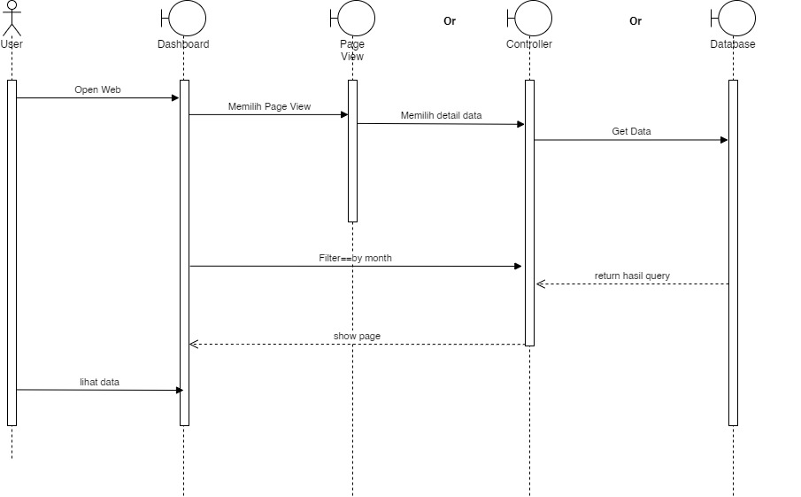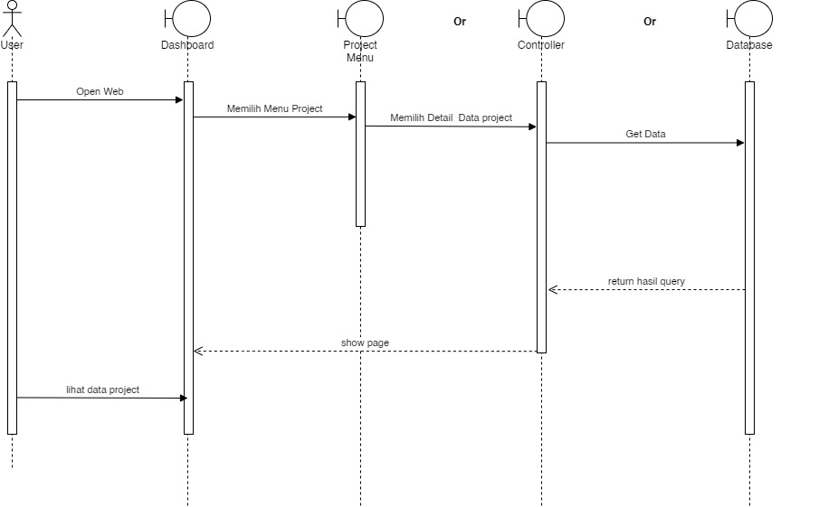

**Kontrak API**

Name: Get list need action

Endpoint: api/user/list-need-action

Method: GET

Auth: basic/bearer

Request body/Param:-

Response 200:

{

“Success”:””,

“Data”:{

},

“Message”: “”,

“Code”: “”

}

Name: Get list reminder

Endpoint: api/user/list-reminder

Method: GET

Auth: basic/bearer

Request body/Param:-

Response 200:

{

“Success”:””,

“Data”:{

},

“Message”: “”,

“Code”: “”

}

Name: Get list approval user

Endpoint: api/user/list-approval-user

Method: GET

Auth: basic/bearer

Request body/Param:-

Response 200:

{

“Success”:””,

“Data”:{

},

“Message”: “”,

“Code”: “”

}

Name: Get list project

Endpoint: api/user/list-project-user

Method: GET

Auth: basic/bearer

Request body/Param:-

Response 200:

{

“Success”:””,

“Data”:{

},

“Message”: “”,

“Code”: “”

}